Monthly Expenses and Savings - Full Answer
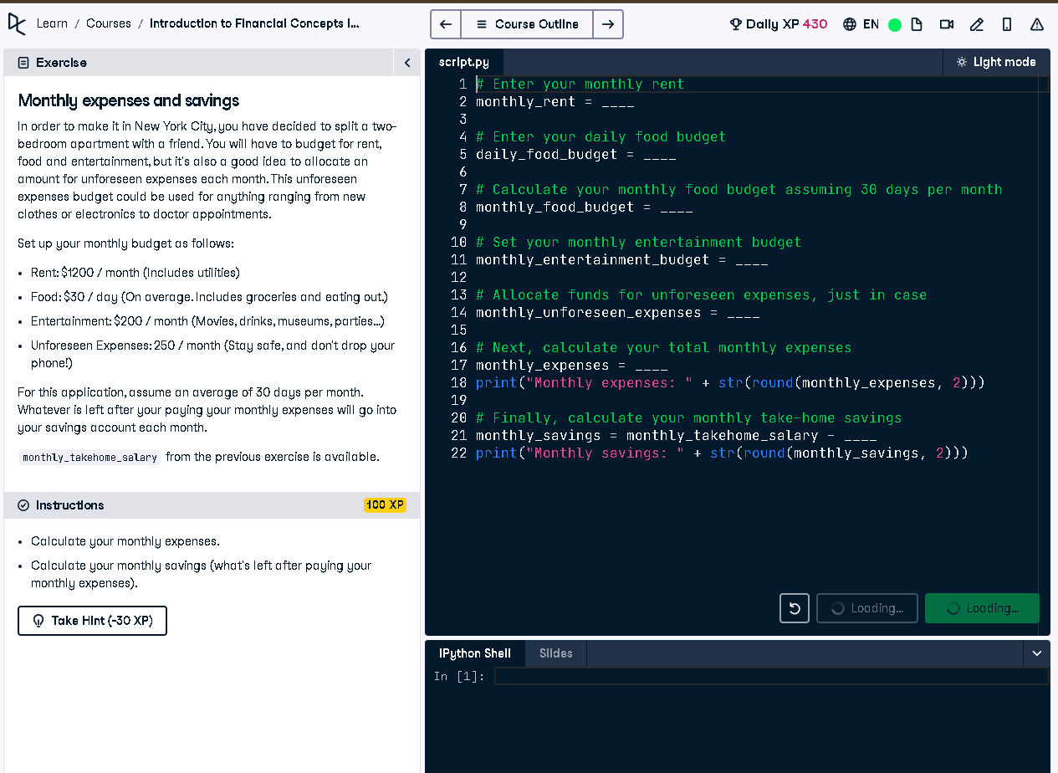

Full Code Answer:
# Enter your monthly rent
monthly_rent = 1200
# Enter your daily food budget
daily_food_budget = 30
# Calculate your monthly food budget assuming 30 days per month
monthly_food_budget = daily_food_budget * 30
# Set your monthly entertainment budget
monthly_entertainment_budget = 200
# Allocate funds for unforeseen expenses, just in case
monthly_unforeseen_expenses = 250
# Next, calculate your total monthly expenses
monthly_expenses = monthly_rent + monthly_food_budget + monthly_entertainment_budget + monthly_unforeseen_expenses
print("Monthly expenses: " + str(round(monthly_expenses, 2)))
# Finally, calculate your monthly take-home savings
monthly_savings = monthly_takehome_salary - monthly_expenses
print("Monthly savings: " + str(round(monthly_savings, 2)))

Question:
How do you calculate monthly expenses and savings with fixed rent, food, entertainment, and unforeseen expenses budgets?

20-word Explanation (Question):
Monthly expenses consist of fixed and variable budgets like rent and food. Remaining income after these is your monthly savings.

Answer:
Sum rent, food, entertainment, and unforeseen costs to get monthly expenses. Subtract from monthly_takehome_salary to get savings.

20-word Explanation (Answer):
Adding all expenses gives total monthly spending. Subtracting this from monthly salary reveals available savings for the month.

